94.08.00d
To Thomas Meehan

[There seems to be no reason why the conventional flowers and plants used to ornament wall-paper, might not be copied from natural flowers, instead of being exaggerations which we so often find them to be. … Through the kindness of Baron Mueller, of Melbourne, Australia, we have been furnished with samples of panel papers, which are models of botanical accuracy, and at the same time would be pronounced as of the highest type of artistic work.]

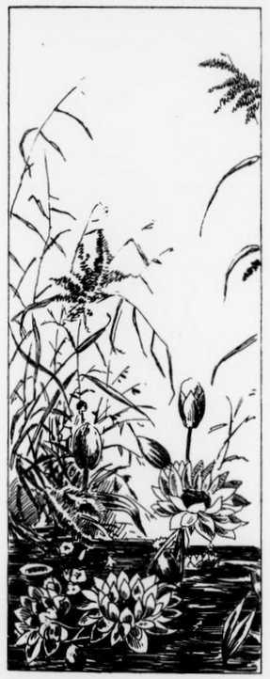

Letter not found. The text given here is from 'Wall-paper flowers', Meehan's monthly, October 1894, pp. 154-5. The letter is dated to August 1894 as the latest likely date that it could have been sent to have been reported in this issue.
The item is accompanied by an illustration 'Panel paper, with the blue Australian lily': 94-08-00d_image01.jpg The source of the samples has not been identified. Since there were no wallpaper manufacturers operating in Melbourne in the 1890s (Professor Miles Lewis, personal communication, January 2019), it is likely that what M sent were sample designs rather than actual printed wallpaper.

